Guidelines for PIs and Co-PIs of RTD Projects
PIs: Principal Investigators
Co-PIs: Co-Investigators

1. General

1.1 As a recipient of a Nano-Tera.ch grant, the Principal Investigator (PI) and his Co-Investigators (Co-PIs) will receive Nano-Tera.ch funding for the Research Technology and Development project entitled Project TITEL based on the official decision by the Swiss National Science Foundation (SNSF) dated December 1st 2008 and sent to the PI.

1.2 As a recipient of such funding, hosting institutions of PIs and Co-PIs must recognize and accept the terms and obligations outlined in the following guidelines. These guidelines also reflect the administrative contractual agreements between the SNSF and the Nano-Tera.ch initiative.

1.3 As Nano-Tera.ch is responsible for the administration and release of the funds, proper documentation from each PI, e.g. from the hosting institution and partner of Nano-Tera.ch must be made available to the Nano-Tera.ch Management Office (MO). This includes all documents relevant to scientific and financial reporting which will serve as a basis for the Nano-Tera.ch global annual report. This global report will be consolidated by the MO and submitted to the SNSF.

1.4 In order for the Nano-Tera.ch RTD projects to be successful, the obligations set out in these guidelines must be respected and fulfilled by each PI who is responsible for the whole RTD project and who also has to ensure that Co-PIs also respect these guidelines.

1.5 These guidelines should enable each RTD project to run smoothly and successfully.

2. Aims and Milestones Planned for:
Project TITEL
2.1 The aims and annual milestones planned for each RTD project are described in the original RTD proposal submitted by the PI by May 1st 2008. This document shall thus serve as a reference for the overall operation and success of the RTD project. The PI is invited to update this document with the completed Nano-Tera.ch budget forms by 28.02.2009 to account for ramping up, shortened project running times as defined by them and to account for matching fund restrictions, budget cuts and in general to the instructions provided in the file entitled “Guidance on final RTD-Project Budget Forms”.

2.2 The PI is responsible for communicating the amended scientific plan to the Co-PIs and others affected within his or her RTD project.

3. Scientific Duties and Responsibilities of the PI

3.1 The PI is responsible for coordinating the project as a whole and assures that the project progresses according to the milestones outlined in the amended proposal (see Section 2). He or she may mandate Co-PIs with appropriate tasks. The PI is also responsible for the monitoring of his Co-PIs and their progress in the project. In cases of disputes among the PI and Co-PIs, the parties are advised to seek their own resolutions. Intervention by the managing bodies of Nano-Tera.ch, however, can occur in extenuating circumstances to resolve the problem.

3.2 The PI is obliged to attend the Nano-Tera.ch meetings of the Principal Investigators and to report on their progress regularly. The annual PI meeting will be called by the EXCOM Chairman according to the Nano-Tera.ch Ordinary Partnership contract.

3.3 The PI is responsible for filing and storing all of the laboratory results and findings in accordance with the rules of their respective hosting institutions. The established good scientific practices are to be implemented. Nano-Tera.ch and the SNSF must be afforded insight into any research documentation at any time. This rule also applies to financial documentation and book keeping.

3.4 The PI must ensure that there is proper and timely information transfers among the Co-PIs and other members of the RTD Project he/she is in charge of. A web based platform structured with secured access per RTD project will be made available by the management office to facilitate this requirement.

3.5 The PI must guarantee his/her commitment to the project beyond his or her association with the “RTD hosting Partner institution”. If the PI leaves his current institution and cannot fulfil his or her obligation as PI from his new post, she/he is obliged to meet with the current hosting institution and the Co-PIs to find a solution which is satisfactory to all stakeholders.

3.6 If the current PI is incapacitated he/she may be replaced. The situation must be directly compromising the success of the RTD project as a whole or a significant part of it. In this case the spokesperson (program leader) of Nano-Tera.ch must meet with the PI’s hosting institution and the Co-PIs and choose a more suitable person to act as PI before the current PI is dismissed.

3.7 The PI is responsible to check for any need of authorization and notification forms for experiments involving living organisms, animals, genetically modified organisms, stem cells, and clinical studies. If such need is identified, the PI is responsible for providing the Nano-Tera.ch Management Office with all the most updated documents. Nano-Tera.ch will not release funding if all required forms are not available as copies in the Management Office. The PI is responsible for making sure updated versions (extensions) are submitted as copies as they become available throughout the project duration.

4. Duties and Responsibilities of Co-PIs

4.1 The Co-PIs of the RTD project are expected to coordinate parts of the RTD relatively independently at their respective institutions. The PI can allow the Co-PIs as much freedom as they deem necessary to carry out their portion of the project successfully. As Co-PIs they should be informed and involved in decisions concerning their research. However, in cases of dispute, the PI will have the final executive decision concerning the direction of the RTD project as a whole. Contrary to SNSF standard funding rules, the Co-PI has no direct claim on any fixed amount of funding allocated to the RTD. As stated above, the PI is in full control of how the Nano-Tera.ch funds are dispersed within the project. This will be done by having the PIs instructing the Management Office of Nano-Tera.ch about the expected distribution of the funds on their project. Co-PIs are, however, encouraged to solicit third party funding options to increase their budgets and capabilities. Any funding awarded to a Co-PI will stay under his control and cannot be claimed by the PI.

4.2 Like the PIs, Co-PIs must guarantee that the experimental findings related to their work are filed and stored accordingly. Please note that rules set in section 3.3 also apply to all the Co-PIs.

5. Scientific Monitoring

Scientific Reporting for Nano-Tera.ch projects will be done as follows.

5.1 The Nano-Tera.ch EXCOM will request annual scientific reports starting end of 2009. The exact form and deadlines for these reports will be communicated in at minimum 3 months up front by the MO. The MO will be responsible for compiling the annual report and transmitting the individual project and overall annual reports to SNSF.

5.2 The SNSF may organize independent SNSF site visits. The SNSF may require an additional independent evaluation and report, organized and managed by the SNSF.

5.3 Finally, the Scientific Advisory Board (SAB) will provide an additional external evaluation of Nano-Tera.ch as a whole but may review specific projects. The Management Office will send out information in due time outlining the form, length, and details for the evaluation.

6. Scientific Reports (see also SNSF Decree)

6.1 The MO will collect the various annual RTD reports and make them available to the appropriate review committees (EXCOM/ SNSF/ SAB). In agreement with the SNSF, the MO will provide the PIs with templates or documents outlining the form that scientific reporting shall have. All reports shall follow this standard so they can be forwarded into the review phase easily.

6.2 The first round of scientific reports will be expected to reach the MO on January 15th 2010. This should represent less than 1 full project year for RTD grant recipients. Exact information concerning deadlines for these scientific reports will be provided by the MO in due time.

7. Rights Concerning Research Results and their Publication

7.1 Before starting the RTD project, the groups involved are responsible for clearing up any issues concerning the rules of handling intellectual property rights such as inventions, software, and the publication of document. As a rule and without specific detailed written agreement between the parties involved, the rules of the hosting institute apply. Also, it is the hosting institution (where the PI is engaged) that leads these negotiations.

7.2 All rights to results generated within an RTD shall belong to those partners which generated the results. Protection and commercialization of such results shall be governed by the respective regulations of this partner. If more than one partner has contributed to results, the involved partners shall agree among themselves upon ownership, rights and strategy of commercialization.

7.3 Although there are currently no venture provisions concerning the ownership or solicitation of intellectual property or patents resulting from Nano-Tera.ch RTD projects in place momentarily among the Nano-Tera.ch partners, Nano-Tera.ch reserves the right to amend this in future. Any such change would involve the consent of all the partner institutions and thus become an official amendment to the existing Ordinary Partnership contract.

7.4 Any publication containing results partially or fully financed by Nano-Tera.ch must acknowledge Nano-Tera.ch as the funding committee. The following acknowledgement form is suggested:
This project was financed with a grant from the Swiss Nano-Tera.ch initiative and evaluated by the Swiss National Science Foundation.

7.5 Nano-Tera.ch grant recipients are fundamentally obligated to make their research results publicly available and to acknowledge Nano-Tera.ch as their funding source. Nano-Tera.ch grant recipients shall make the results form their Nano-Tera.ch projects available electronically to the general and scientific public.

8. Public Service and Press Releases

8.1 Nano-Tera.ch funds come from public tax money. In this context, the public should be allowed appropriate access to information concerning the research outcomes and overall scientific benefit which ensued as a result of this investment. For more information concerning this point please see section 7.5.

8.2 For press releases containing all or parts of the activities or results from RTD projects, the Management Office must be contacted in advance.

9. The Financial Monitoring Committees

9.1 The financial reports will occur separately from the scientific reports. They are bound to the calendar year. This means each PI and Co-PI is responsible via his financial and controlling department to submit a financial report for his activity on the entire project for each calendar year it runs. The deadline for each calendar year financial report is December 31st. Similar to the scientific reports, the financial reports will be reviewed internally and externally.

9.2 The financial reports are to be submitted to the MO in the form dictated in the “Nano-Tera.ch Financial & Controlling Handbook”. The financial reports will be consolidated for internal assessment by the Steering Committee.

9.3 The external audit of the consolidated financial report will be done by a private company.

10. Financial Responsibilities of PI

10.1 Besides the financial responsibilities mentioned in the SNSF decree, the PI is free to shift yearly funding according to the needs of the project (see also section 4.1) or as a measure to absorb unforeseen complications or dynamics of the RTD project he or she is leading. As all of the funds need to be matched by at least 100%, with requested matching funds set at 53% on an per institutional basis, the institutional contribution discrepancies must be addressed early to ensure proper matching of received money.

10.2 In addition, the PI is responsible for monitoring and preventing the accumulation of large amounts of Nano-Tera.ch funding money within each funding year. No general accumulation of funds without specific allocations is permitted. Money which accumulates at the end of the year without a specific allocation and/or written justification in the financial reporting may not be rolled over to the next year’s budget and may be retracted by Nano-Tera.ch in accord with the SNSF. Gross mismanagement of funds and/or negligence in financial reporting may also lead to financial sanctions imposed by the SNSF and Nano-Tera.ch. Please also refer to the section Budget Cuts and Termination (‘Beitragskürzungen und Abbruch’) in the SNSF Decision.

10.3 Nano-Tera.ch grant recipients who pay all or parts of employee salaries with Nano-Tera.ch money must ensure that there is a written contract between the employing institution and the respective employee. The rules and conditions of the contracts fall under the jurisdiction of the employing institution and the Canton laws concerning employment. This is not the business of Nano-Tera.ch. No employee has direct claims on salaries via Nano-Tera.ch. Nano-Tera.ch grant recipients shall be afforded fair co-determination rights in terms of their scientific contributions which are later published or otherwise communicated.

10.4 Generally all equipment and other material purchased with Nano-Tera.ch money will remain in the possession of the respective institution at which the grant recipient is affiliated. Guidelines concerning the further use of this equipment after the duration of the RTD project should be made internally. In special cases Nano-Tera.ch may lay claim to certain pieces of equipment. This may occur in cases where the equipment will no longer be used in its current institution or if another Nano-Tera.ch funded project needs exactly the same equipment.

11. Own Contributions

11.1 Each of the involved institutions’ signs ‘own contribution’ commitments (“in kind” and “in cash”) pertaining to the entire RTD. The amounts allocated to this project by the various institutions are summarized in the table below. Contributions “in cash” are subject to internal procedures of the respective institutions. Certain contributions will be provided to the RTD project only if and when the responsible committee approved the respective application.
If a certain partner institution falls behind on their own contributions, the PI should contact the Co-PIs at the respective institutions who should then contact the university management for clarification. If there is a discrepancy within the consortium due to reallocation of monies by the PI during the project, the PI might be asked to explain his funding decisions. However, this should not serve as a basis for individual institutions to withhold the funding they committed to at the beginning of the project. In extenuating circumstances, the Management Office should be contacted.

Tables of Own Contributions *
Updated final data requested below are to be copied here from the finalized budget forms for each institution involved on the cited approved RTD project (please replace the present illustrations below and provide the requested total own contribution):

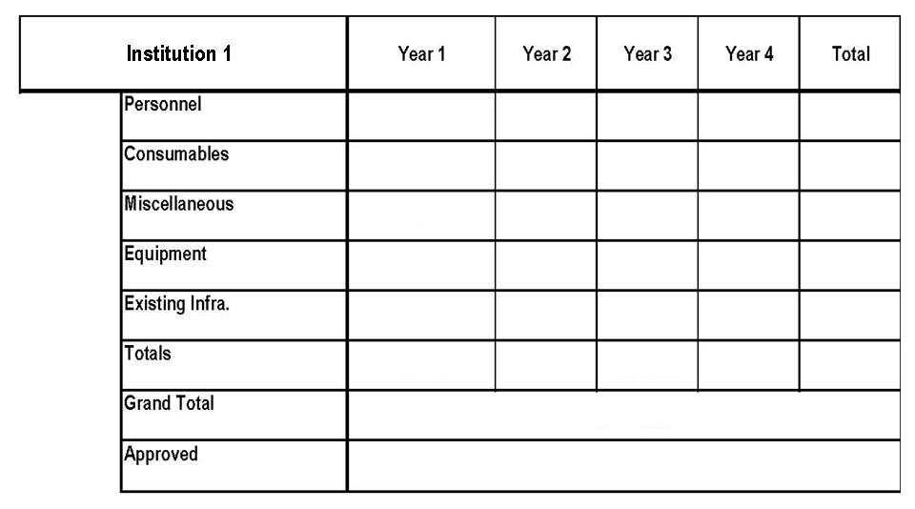

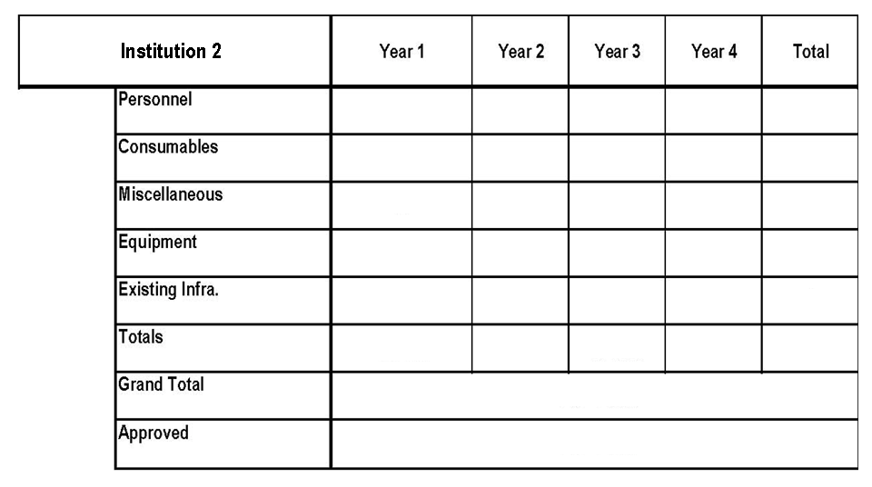

Etc.

Total Own Contributions: CHF _ _ _ _ _ _ _ _

* Some projects may run for 3 years, while others run a full four years. The amounts in the table reflect project years and not the financial years. Consequently some projects will report until 2011-2012 while others run into 2012-2013.

12. Second and third Party Funding

12.1 Nano-Tera.ch encourages all participants in a RTD project to solicit second (SNSF, CTI, EU, etc.) and third party funding (industry-collaborations) to help support and promote the success of their project as a whole. In case of second and/or third party interaction, the PI or responsible investigator may be required to enter into a contractual agreement with those second and third parties. Contracts with second and third parties for RTD projects are subject to the rules of the hosting institution. Please note that second party funds do not count as matching funds.

12.2 The PI is responsible for cross-checking the terms and conditions of additional collaborative contracts for conflicts with these RTD guidelines. For such third party contracts please contact the relevant science and technology transfer offices or legal services for support. The collaborative party should be especially mindful of things like intellectual property rights, patents, and data sharing contingencies which may be part of such a contract and which conflict with the aims and mission of the Nano-Tera.ch initiative.

13. Self Declaration / Good Governance

13.1 The annual financial reports submitted for Nano-Tera.ch projects include (1) Nano-Tera.ch Funds, (2) Own Contributions, (3) Second Party Funds and (4) Third Party Funds (industry-collaborations).

13.2 The PI and all Co-PIs guarantee that the funding he or she receives for the above mentioned RTD project will be used solely for activities related to this particular project. He or she will not allow any portion of these funds to be used to obtain additional funding without claiming it in the annual financial report.

13.3 Signing the annual report means the PI and all Co-PIs attest that the reported Own Contributions reflect the truth, in particular the stated percentages for personnel and equipment. For the financial reporting, each institution provides a contact person from their Finance and Controlling division, who will provide the researchers with financial reporting support.

13.4 The PI commits to good governance practices both in the scientific and financial reporting associated with this RTD project.

14. Right of Inspection

Both the PI and the hosting institution have the right to inspect all official reports pertaining to Nano-Tera.ch. This includes all documents received by the Management Office from the SNSF concerning the progress of the RTD projects and their financial and scientific reports. In addition the PIs and their hosting institution may request copies of the reports resulting from the EXCOM after the midterm review in 2011.

15. Nano-Tera.ch Corporate Identity and Logos

Nano-Tera.ch is a registered trademark. As a recipient of Nano-Tera.ch funding, PIs are given written notice concerning the existence of Nano-Tera.ch associated logos for their respective projects. The use of these logos is limited to the funding duration of the respective project.

16. Additional Documents

There are further documents which might be consulted in case of particular issues. All documents are available at the Management Office:
- • Nano-Tera.ch Ordinary Partnership Contract: January 2008
- • "Décision présidentielle de financement, projet A-02, période 2008-2011" of the ETH-board "Initiative national pour les sciences des ingénieurs : l’ingénierie et la technologie de l’information pour la santé et la sécurité des êtres humains et de l’environnement", 22.04.2008
- • Administrative Agreement between the Swiss National Science Foundation (SNSF) and Nano-Tera.ch

17. Acceptance by Signature
These Guidelines have been acknowledged and accepted by:

1.

……………………………………………… …...................
Project PI: __________ Date
Institution 1

2.

……………………………………………… ……………….
Project Co-PI: __________ Date
Institution 2

3.

……………………………………………… ……………...
Project Co-PI: ____________ Date
Institution 2

4.

……………………………………………… ……………...
Project Co-PI: ____________ Date
Institution 3

Etc.

